**Kandukuri Pavan Kumar**

Git: https://github.com/pxk09750/Neural-Assignment.git

Problem -1:

In class programming:

1. Create a class Employee and then do the following

• Create a data member to count the number of Employees

• Create a constructor to initialize name, family, salary, department

• Create a function to average salary

• Create a Fulltime Employee class and it should inherit the properties of Employee class

• Create the instances of Fulltime Employee class and Employee class and call their member functions.

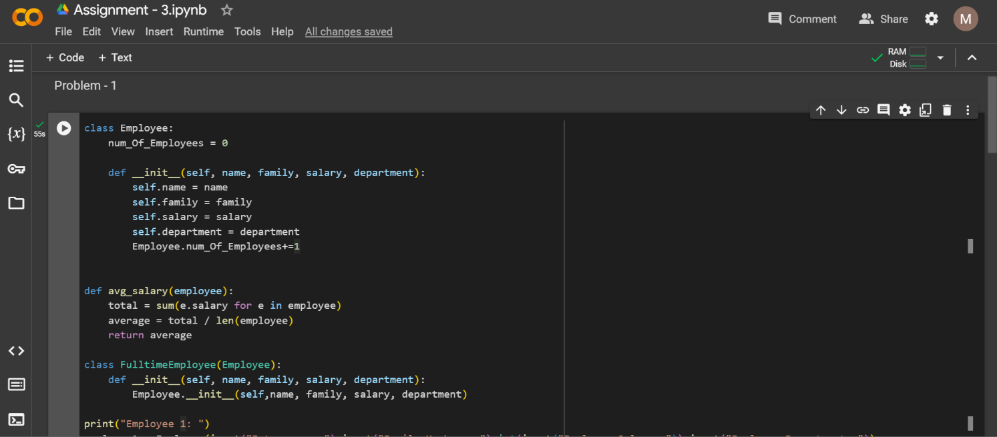

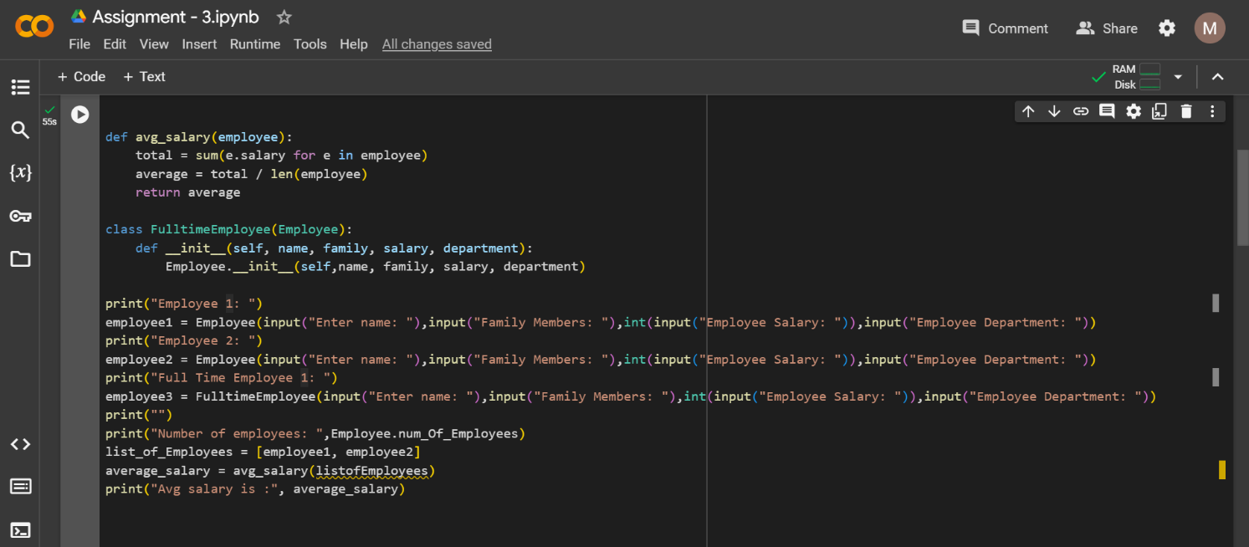

Output:

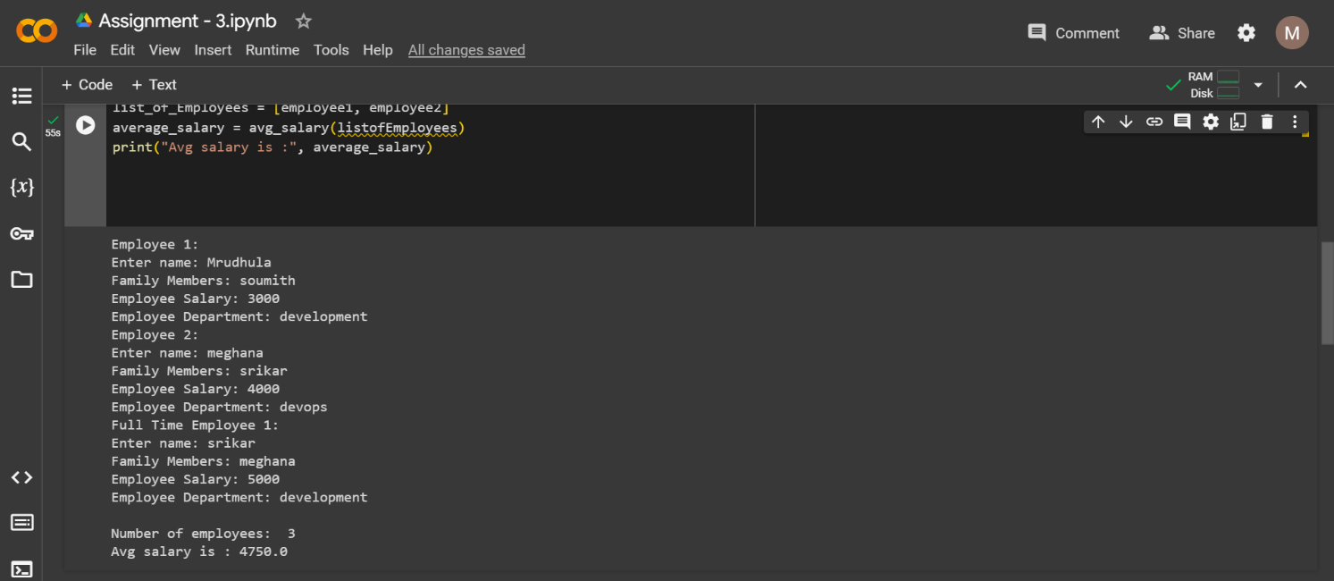

Problem – 2:

2. Numpy

Using NumPy create random vector of size 20 having only float in the range 1-20.

Then reshape the array to 4 by 5

Then replace the max in each row by 0 (axis=1)

(you can NOT implement it via for loop)

